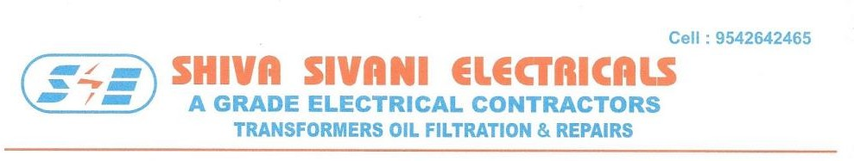
APPROVED BY C.E.I.G., LICENSE NO: CEIG/TS/OTK NO.02/D.NO.229/2024 DT: 19-02-24 to 22-02-27
(As per IS: 6792-1972 with 2.5mm gap) TRANSFARMER OIL TEST CERTIFICATE
To, SL NO: 082/2025
M/s. SILVER PRINTS PVT LTD, DATE: 29-11-2025
93&94 A.P. APPAREL PARK, GUNDLAPOCHAMPALLY, MEDCHAL MDL, HYD-14.
TRANSFORMER DETAILS | MAKE : ESENNAR | QTY OF OIL : 1160 Liters
 | RATING: 630 KVA | MFG YEAR : 2017
 | VOLTAGE RATIO: 11/0.433KV | SL NO OF TF : ET2-8009

- DIELECTRIC STRENGTH OF TRANSFORMER OIL: Before Filtration/After Filtration.

SAMPLES | VOLTAGE APPLIED | TIME IN SECONDS | VOLTAGE APPLIED | TIME IN SECONDS | CONDITION OF THE OIL OK/ UNSATISFACTORY
BOTTOM I | 28KV | 60 | 60KV | 60 | OK
BOTTOM II | 29KV | 60 | 60KV | 60 | OK
TOP | 28KV | 60 | 65KV | 60 | OK
NOTE: Testing Method as Per IS 6792-1992.
Min.BDV as per IS 1866:200 30kv at 60Sec is Considered to be good. If Less Than that oil should be filtered.

- INSULATION RESISTANCE OF WINDINGS IN MEGA OHMS:

H.T SIDE |  |  | L.T SIDE |  |  | H.T To L.T |  |  | RESULTS
R.E | B.E | Y.E | R.E | B.E | Y.E | R.R | B.B | Y.Y
1600 | 1600 | 1600 | 1500 | 1500 | 1500 | 1600 | 1600 | 1600 | OK

- ACIDITY OF TRANSFORMER OIL

0.03 milligram of KOH per gram of oil | Result : |   OK |  | UNSATISFACTORY
